From one of our Operators –

There is a project addressing flushable wipes through the Water Services Association of Australia (WSAA). I know very little about it, other than its existence. Project description is as follows:

*Wet wipes are increasingly becoming an issue for the urban water industry. WSAA are developing a work program for how we will tackle the problem as an industry. Likely solutions include enhanced labelling, working to change the product requirements, and education of customers*.​

Answers to Journalist’s Questions

1. What percentage of blockages in Goulburn Valley Water's sewer systems are caused by disposable wet wipes, nappies and incontinence pads?

It’s often very difficult to determine what is actually causing a blockage. As mentioned in Q2, often tree roots create a surface that other materials can then stick to, so when the guys clear it, they could often see roots and fats/grease and rags and whatever else come out. Despite those difficulties we do ask the guys to submit a cause of blockage within the FOCUS case, but we don’t go into that much detail.

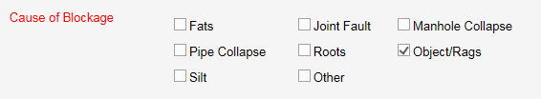

1. Do they cause a bigger problem than, say, tree roots and plastic bags?

If there are tree roots involved then they are the main concern as they trap all other material, which in most cases causes the blockage.

1. What percentage of blockage call-outs a year are due to wipes, disposable nappies etc?

As with Q1

1. When did it start becoming a problem, assuming it has?

Foreign materials in sewers have always been an issue I think it has just increased in the last few years? Bit hard to say for certain. From memory I think our blockage rates have been pretty steady the last few years and while wet wipes may be impacting this, we have also improved our sewer CCTV inspection program and invested substantially more into our sewer main replacement/rehabilitation programs. A number of other factors can influence blockage rates such as rainfall – During dry conditions trees roots can become more aggressive as they search for water, and rainfall events can have a flushing effect on the sewerage network. Water usage – Low water usage results in less sewer flows, which can cause solid materials to settle out, or stick to tree roots or other things that can trap them.

1. Has this percentage increased/decreased/stayed flat?

Too hard to say

1. What does this cost GVW or what does it cost to clear a blockage each time?

A blockage in a sewer main takes about 2 to 3hrs (depending on traveling) therefore, 3hrs for 2 men @ about $50hr (depending if after hrs) = $300 and a ragged up pump or blockage in a pump is about the same.

1. How often do pipes/pump stations have to be cleared of blockages caused by wipes?

Again, we don’t go into specific details about what caused a blockage of a pump.

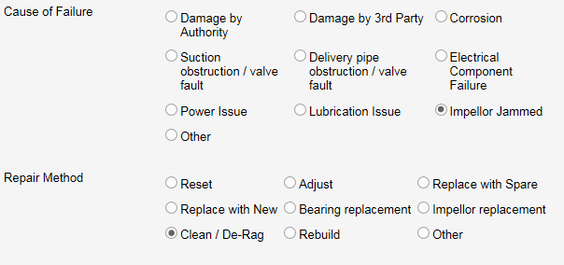

1. How many pump stations does GVW have?

267 Sewer Pump Stations (SPS)

1. Is this where the blockages occur mostly?

Blockages happen in sewers, pump stations usually have pump fowling (ragged up) or a floating mass that cause problems and call outs etc.

Sewers block more often mostly (95%) due to tree roots.

1. When did GVW first notice that wipes were causing problems and blockages?

It is not just wet wipes GVW has a problem with all foreign matter being disposed of via the sewer. Foreign matter not only causes sewer network problems it can cause issues at waste water treatment plants.

1. Do some sites tend to be more vulnerable than others? Where’s the worst one and what area does this feed from?

We have some areas that suffer from more blockages than others. Measuring by blockages/km of sewer (from the last couple of years) Top 5 towns in GVW are;

1. Tatura

2. Alexandra

3. Kyabram

4. Mooroopna

5. Seymour

1. Can you explain why this might be?

As with most of this stuff, it’s difficult to pin down. Soil type/ground conditions, age of network, depth of sewers, quality of construction.

1. What efforts is GV Water undertaking to change wipes/ nappy/incontinence pad dumping into loos?

There is a link on our website that encourages customers not to dispose of these products via the sewer. There are peak water industry bodies that are working with various manufactures and supermarkets. Other large water businesses are leading the way. GVW, being a smaller business, does not have the resources to contribute other than in-kind support.

1. If people stopped dumping wipes, nappies and incontinence/menstruating pads down loos in your region tomorrow, what would this save you annually?

No idea!

An addition from the community education team – the education programs we run focus on what not to flush and children are learning, but it will take a number of years before these messages are commonplace, and will be reliant on industry standards shifting with regard to labelling.